**Setting Up Jenkins Pipeline to Deploy Docker Swarm.**

>Instance Creation

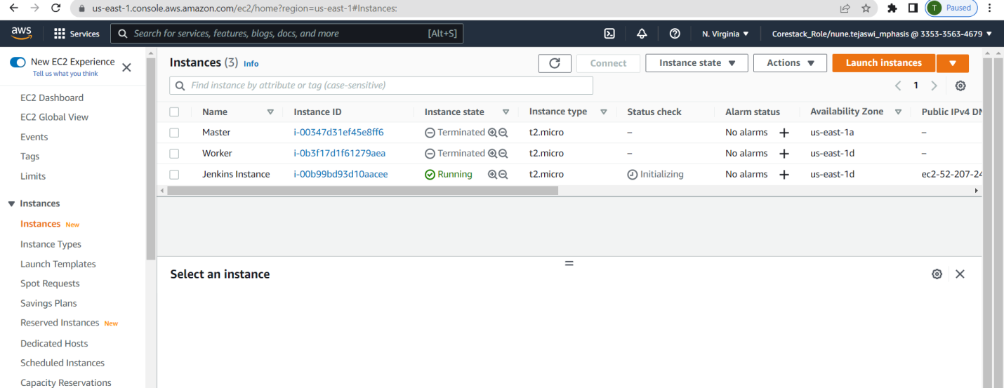

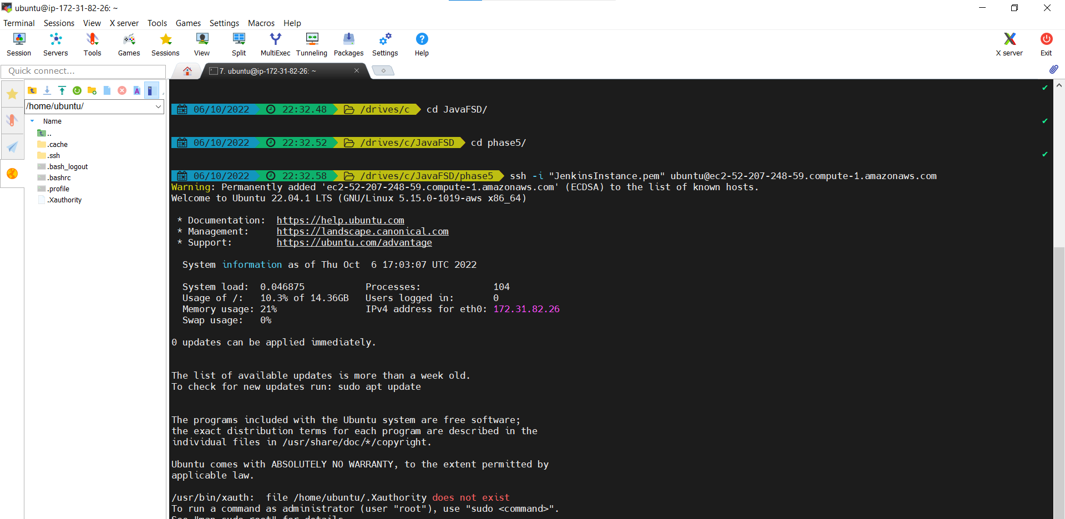

**> DOCKER INSTALLATION ON UBUNTU OS**

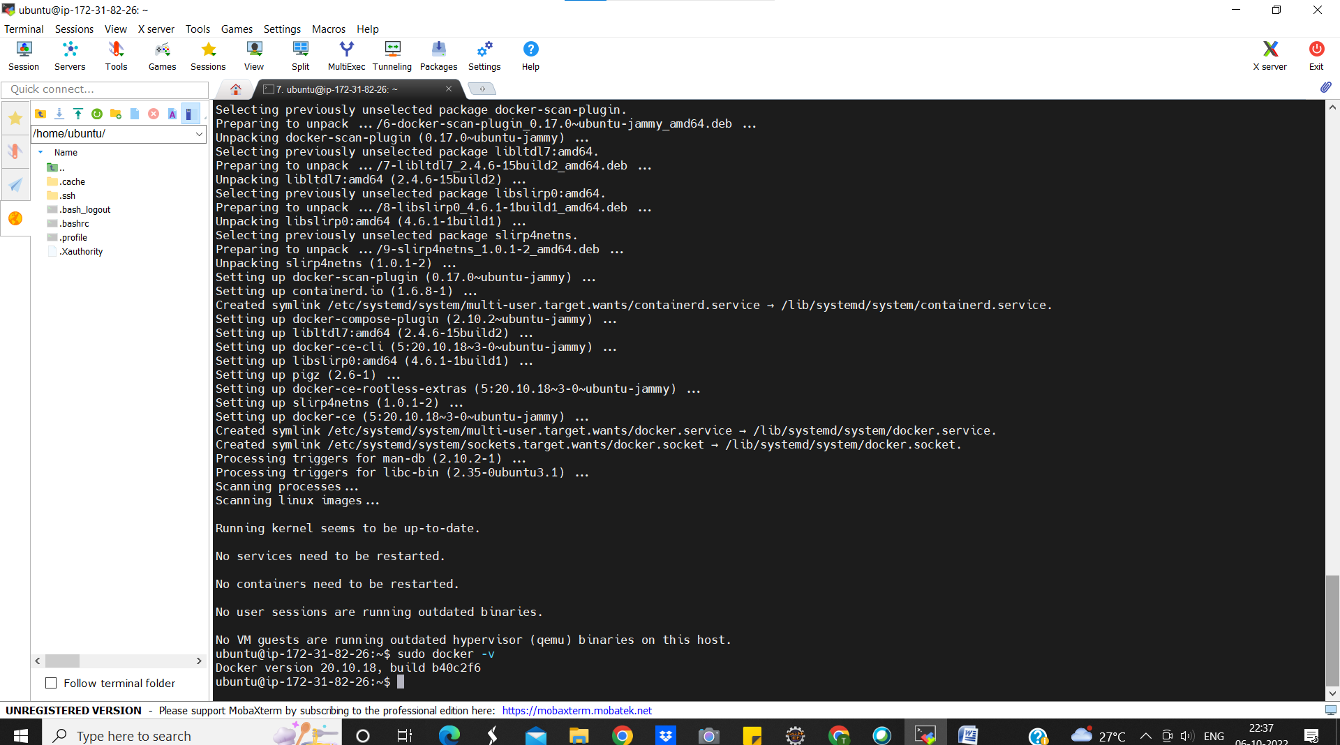

**>INSTALL JDK**

->sudo apt-get update

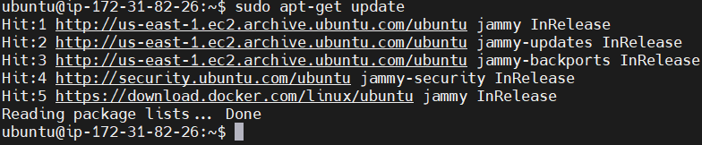

->sudo apt install default-jdk –y

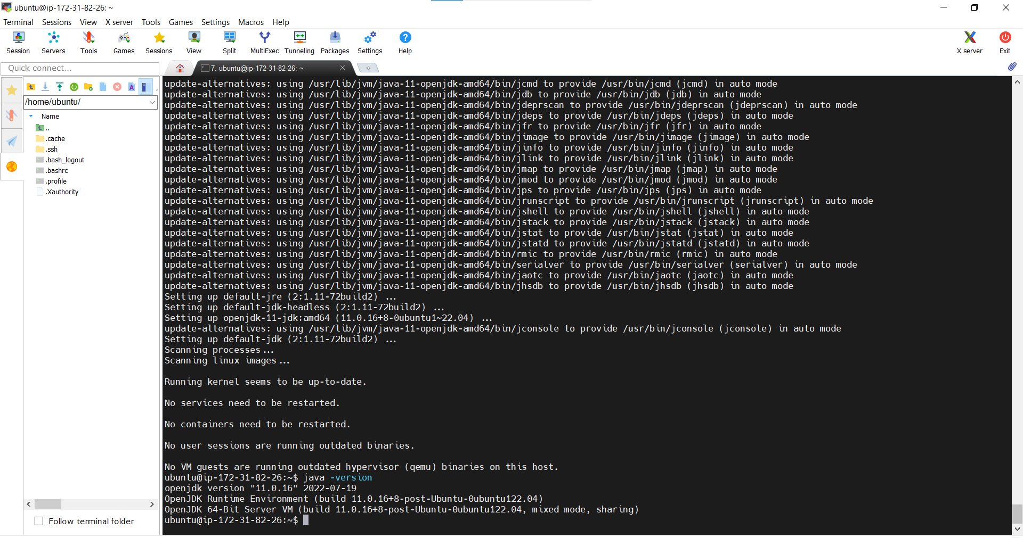

>**INSTALL MAVEN**

->sudo apt-get update

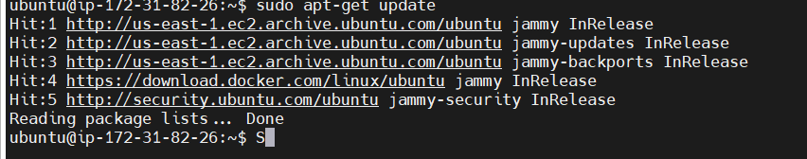

->sudo apt install maven -y

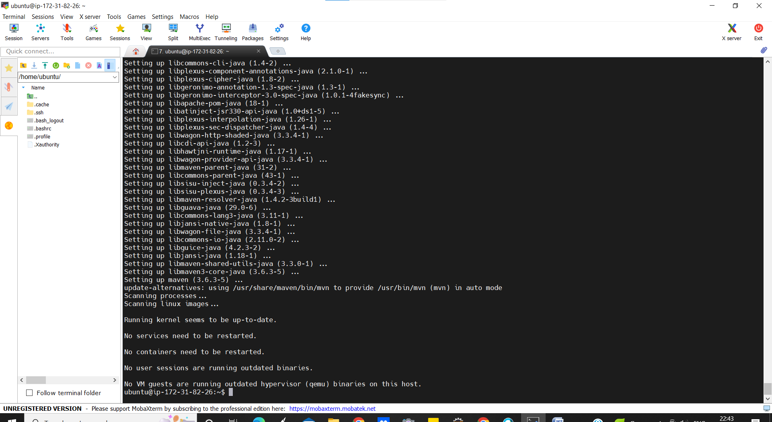

>**INSTALL JENKINS**

->curl -fsSL https://pkg.jenkins.io/debian-stable/jenkins.io.key | sudo tee /usr/share/keyrings/jenkins-keyring.asc > /dev/null

->echo deb [signed-by=/usr/share/keyrings/jenkins-keyring.asc] https://pkg.jenkins.io/debian-stable binary/ | sudo tee /etc/apt/sources.list.d/jenkins.list > /dev/null



->sudo apt-get update

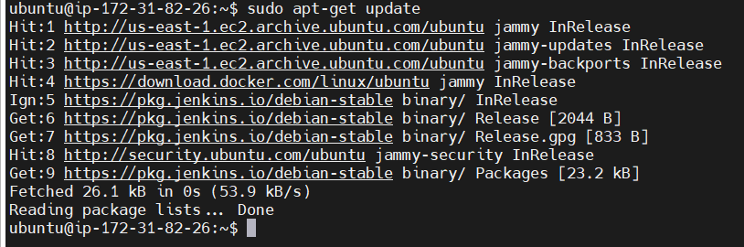

|  |
| --- |
|  |
|  |
|  |

->sudo apt-get install jenkins

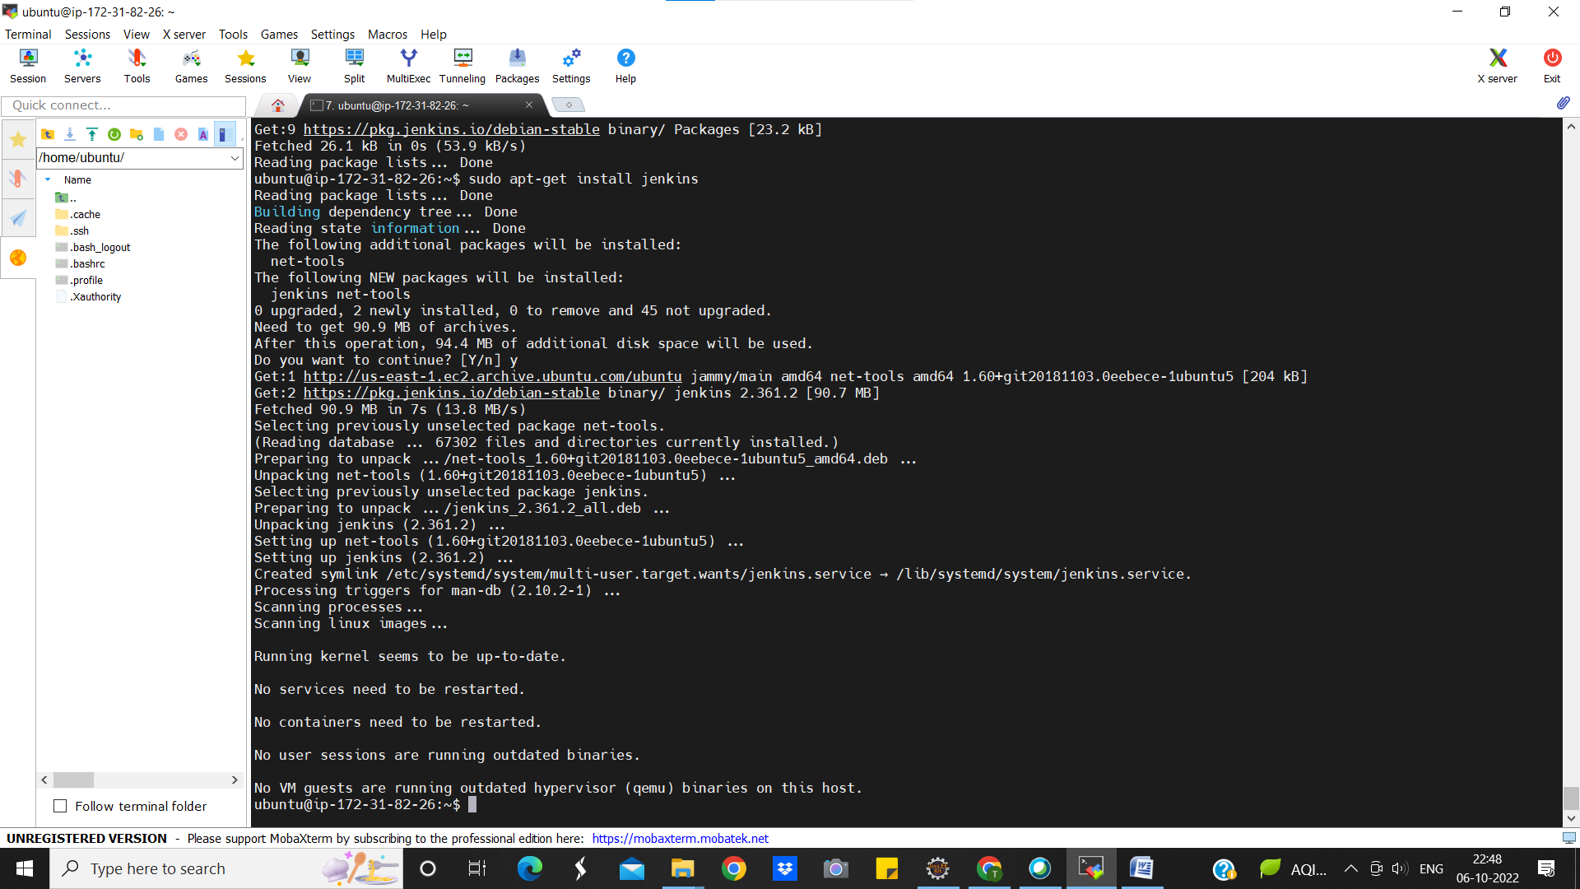

1. **TO START WITH JENKINS**

->sudo service jenkins start

->sudo service jenkins status

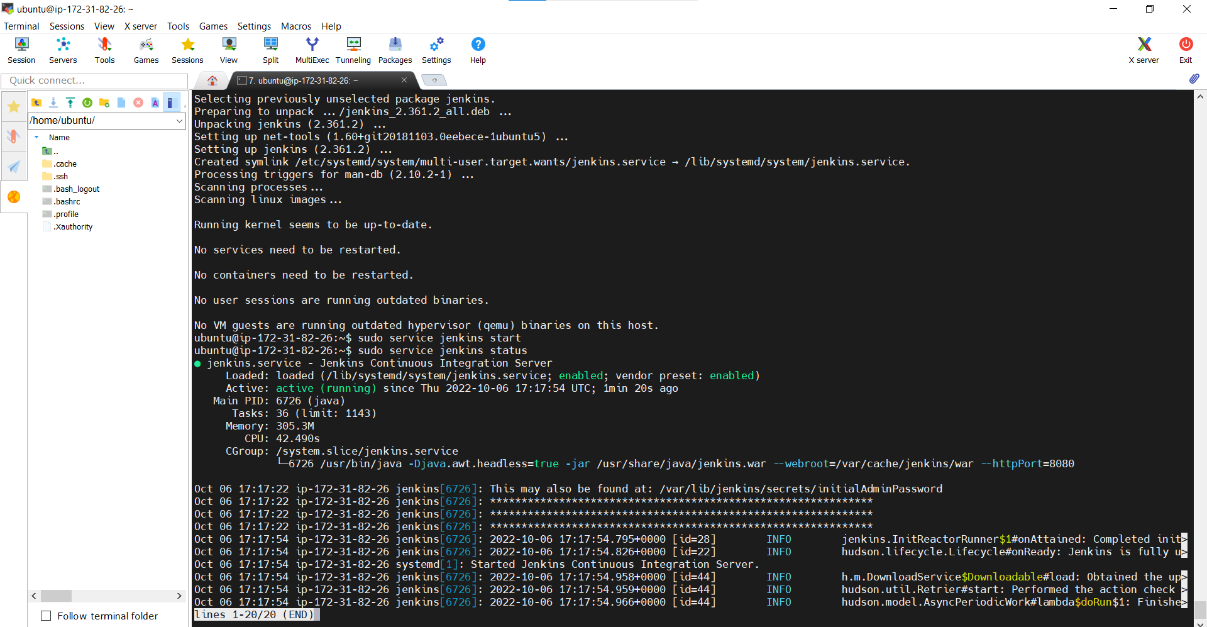

**CONNECT:** goto> AWS>EC2>Copy Public IP:8080 on browser hit enter

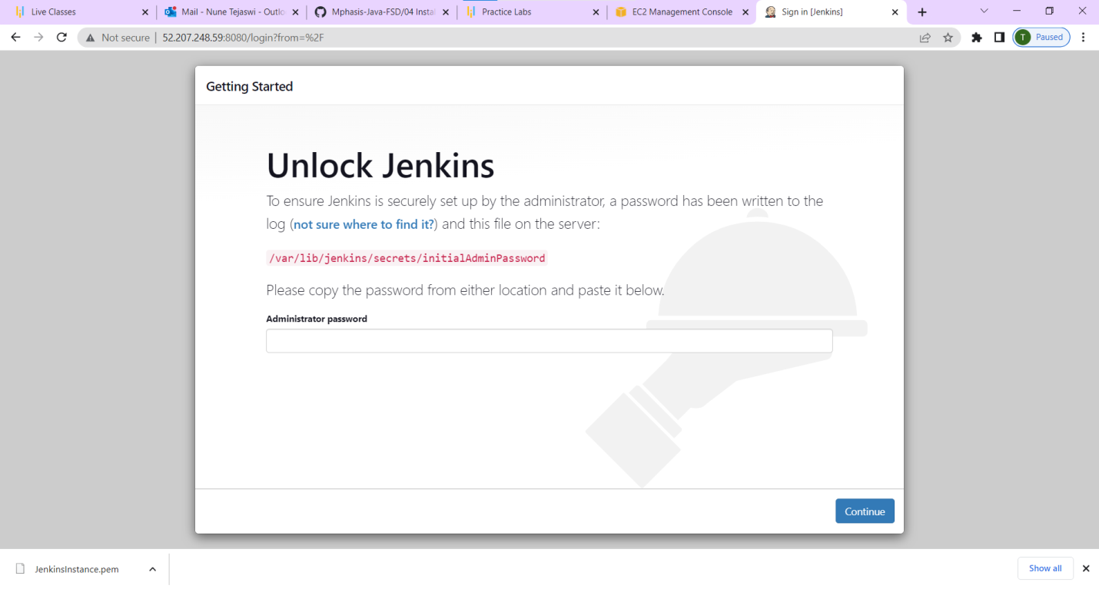

1. **TO GENERATE SECRET PASSWORD**

->sudo cat /var/lib/jenkins/secrets/initialAdminPassword

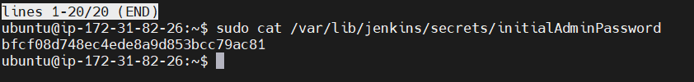

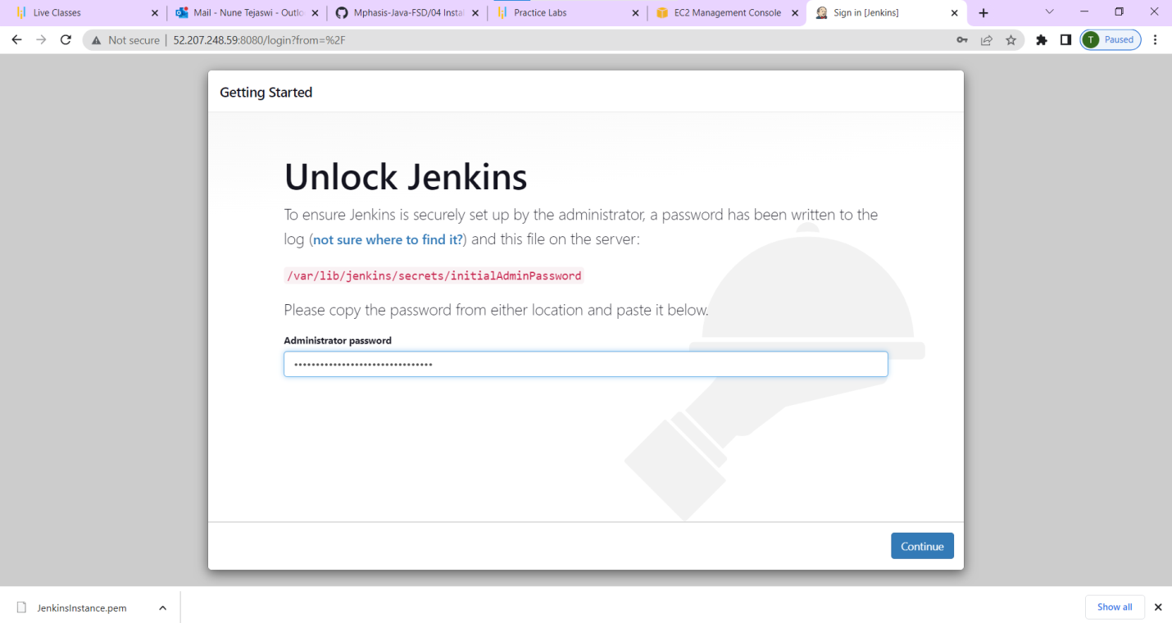

**To deal with permission denied error**

->sudo chmod 777 /var/run/docker.sock

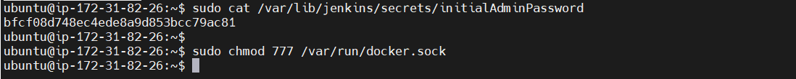

Now this will enable all the permissions

->copy the secret password to jenkins and start installtion

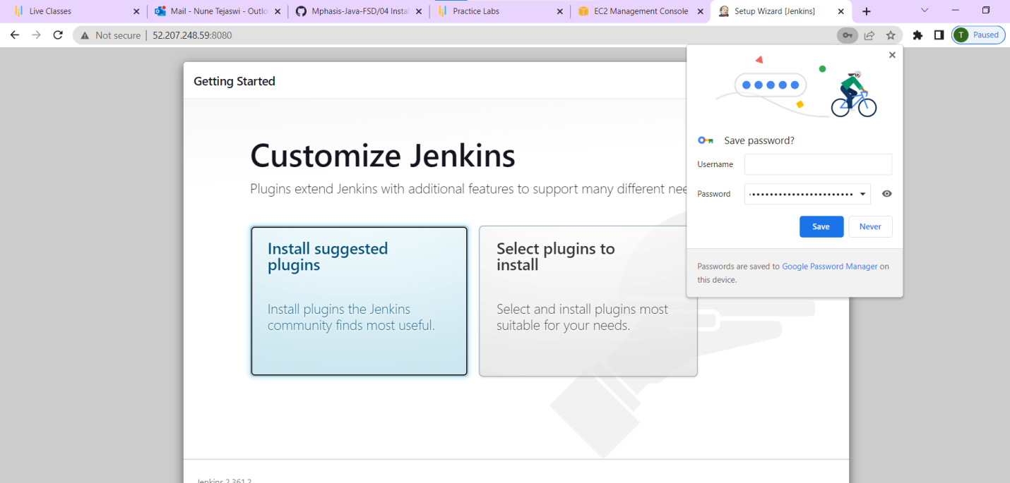

1. **FOR CONTINUOUS INTEGRATION (CI)**

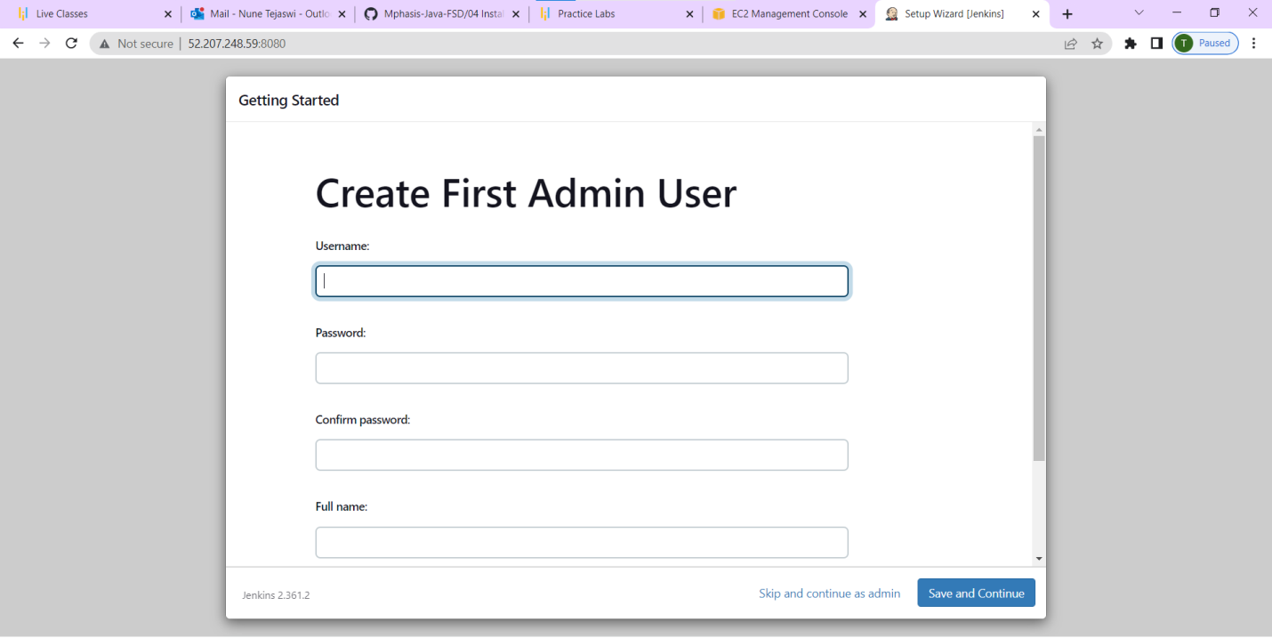

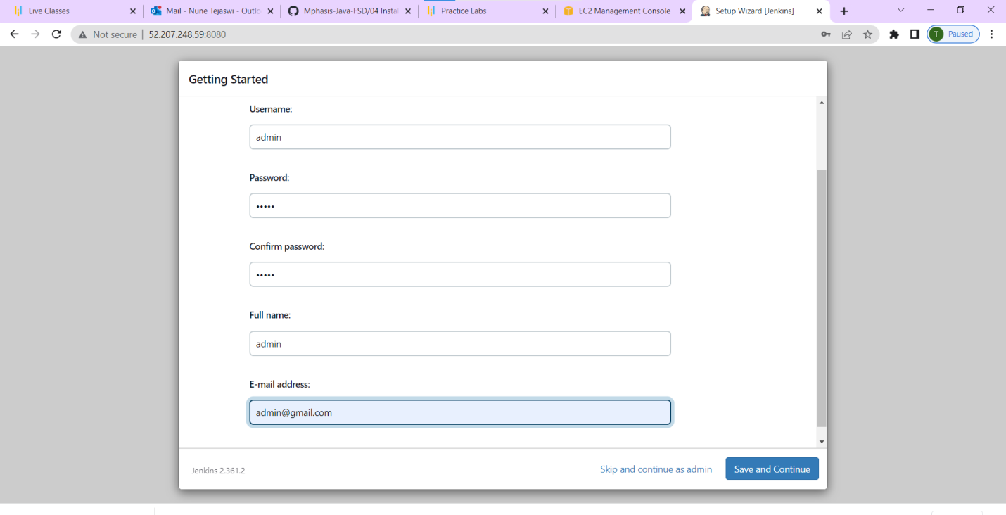

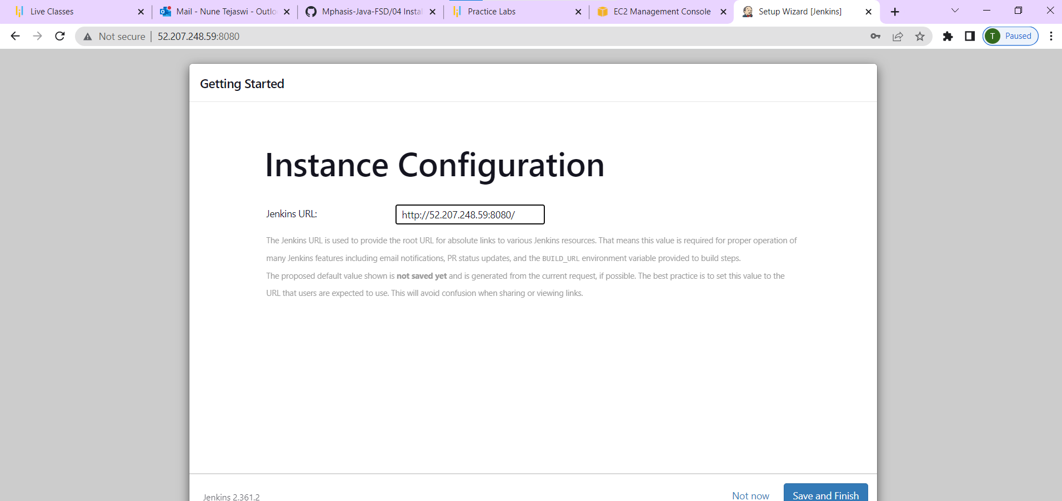

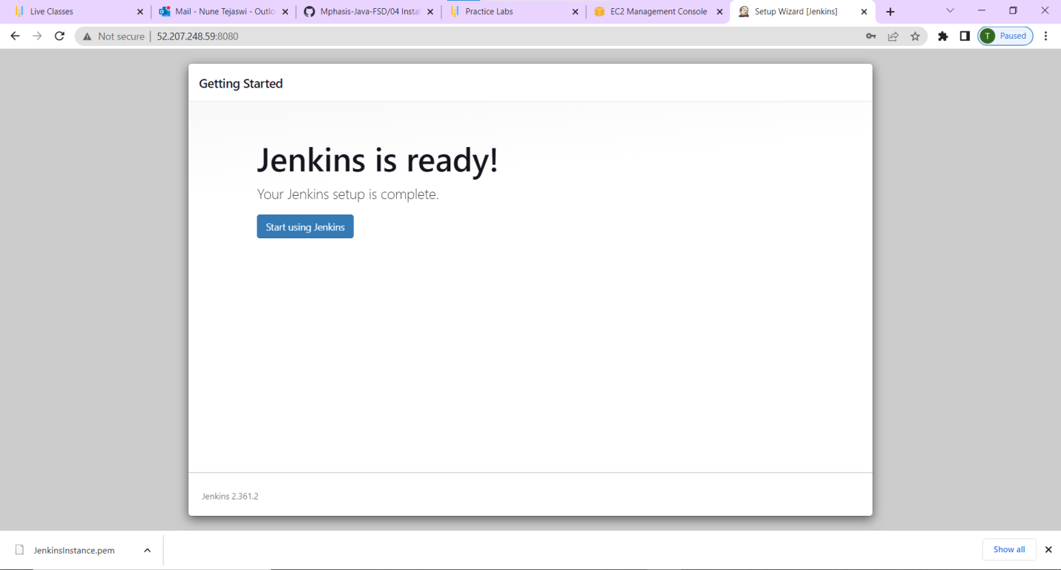

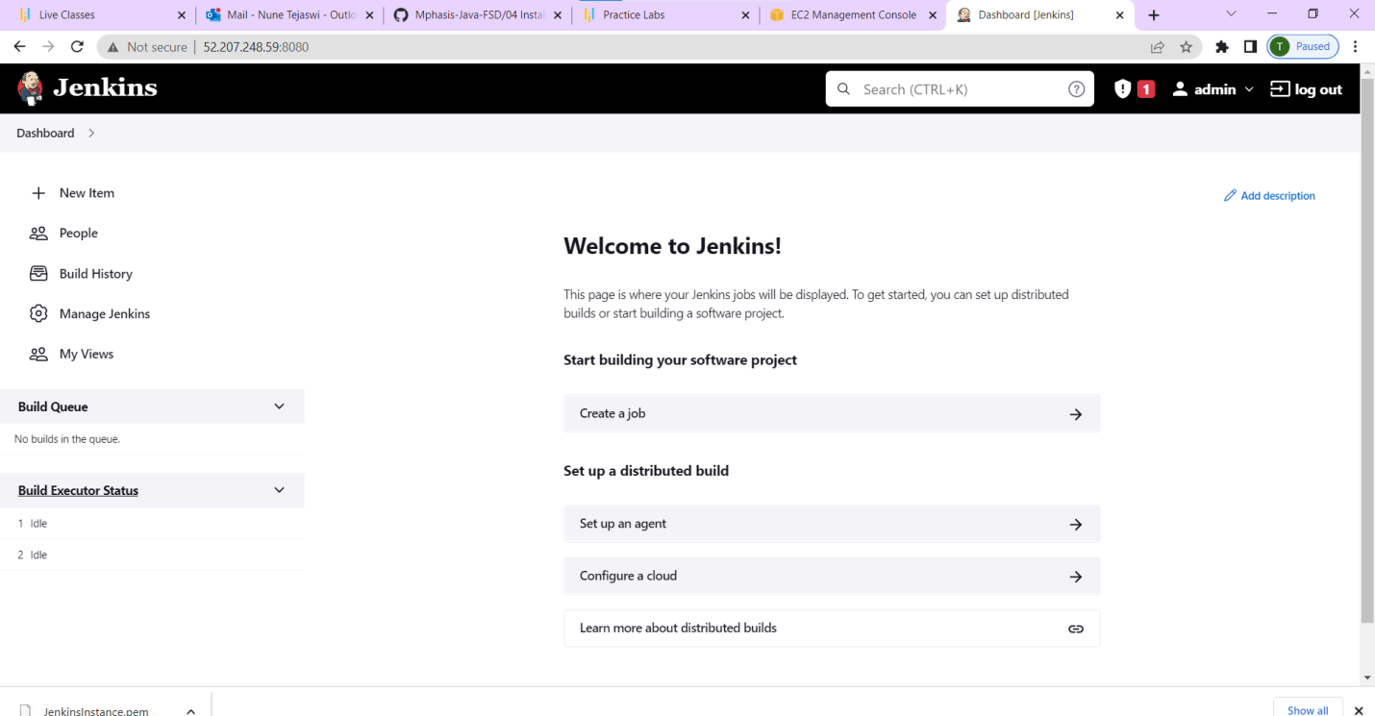

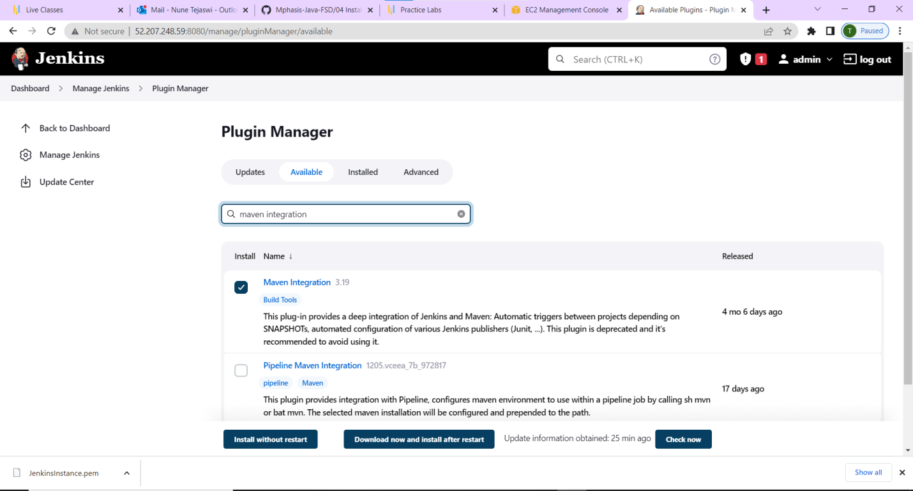

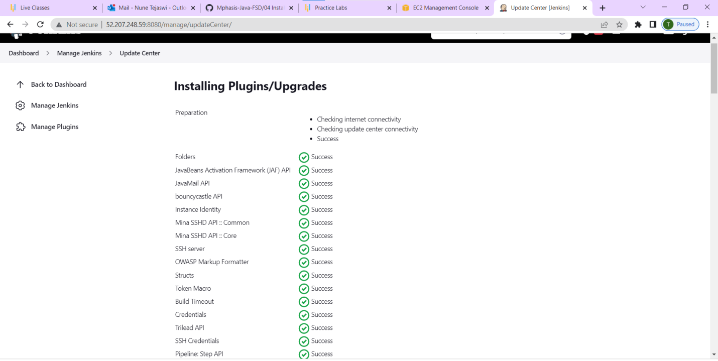

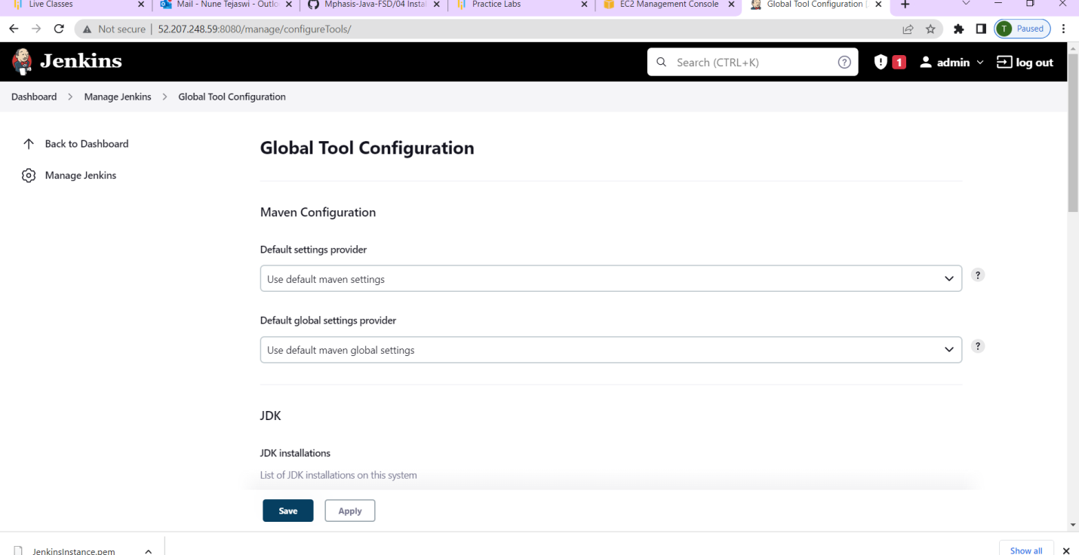

**>Back to Dashboard and click on new item**

**>Go to newfile and enter pipeline**

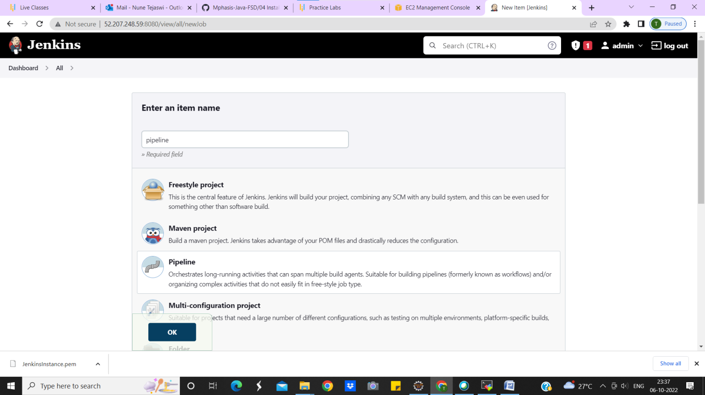

**>And click ok**

**>Now we get a pipeline script**

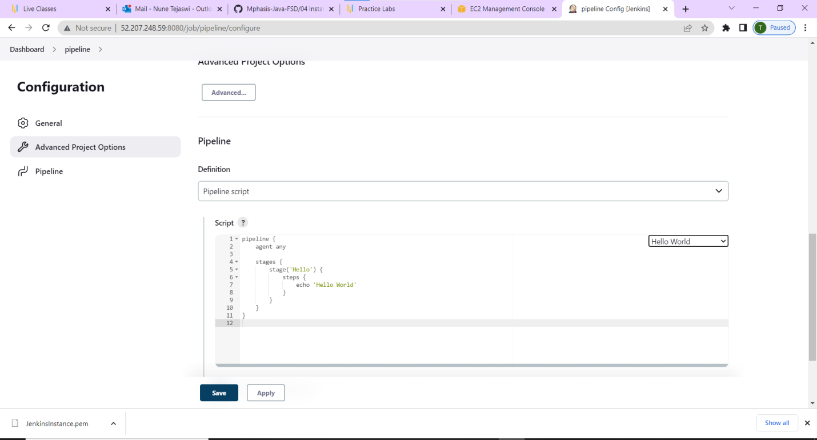

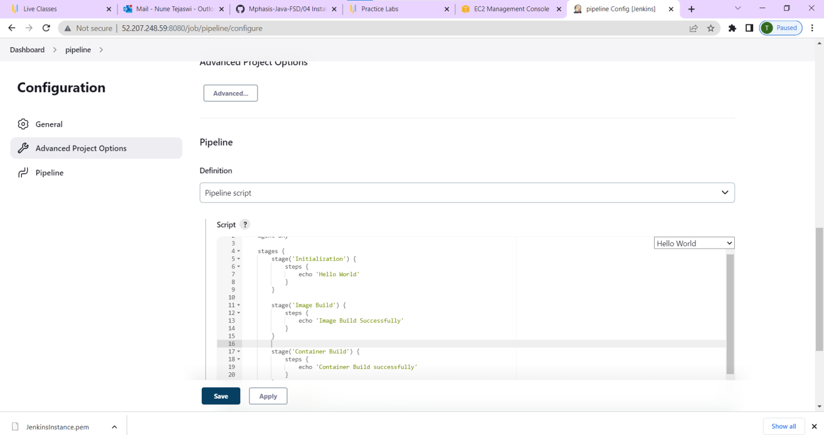

**>Click on apply and save**

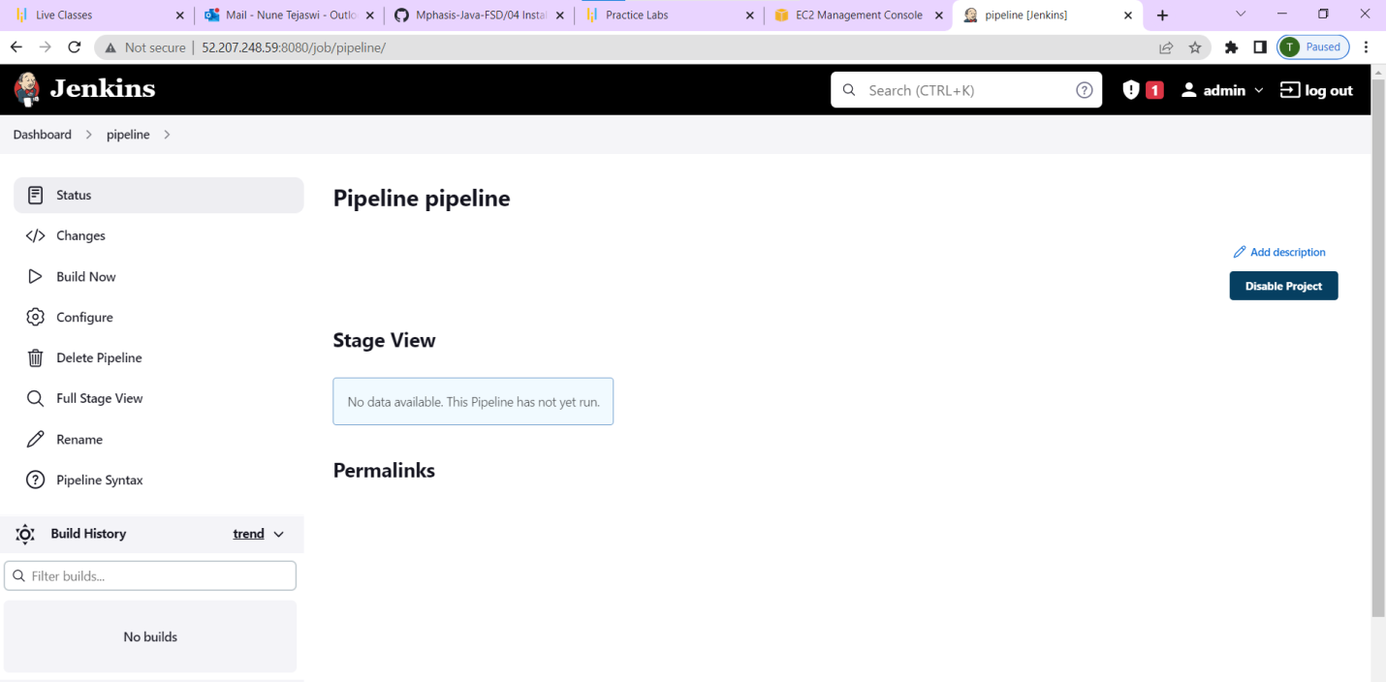

**>Now im going to build**

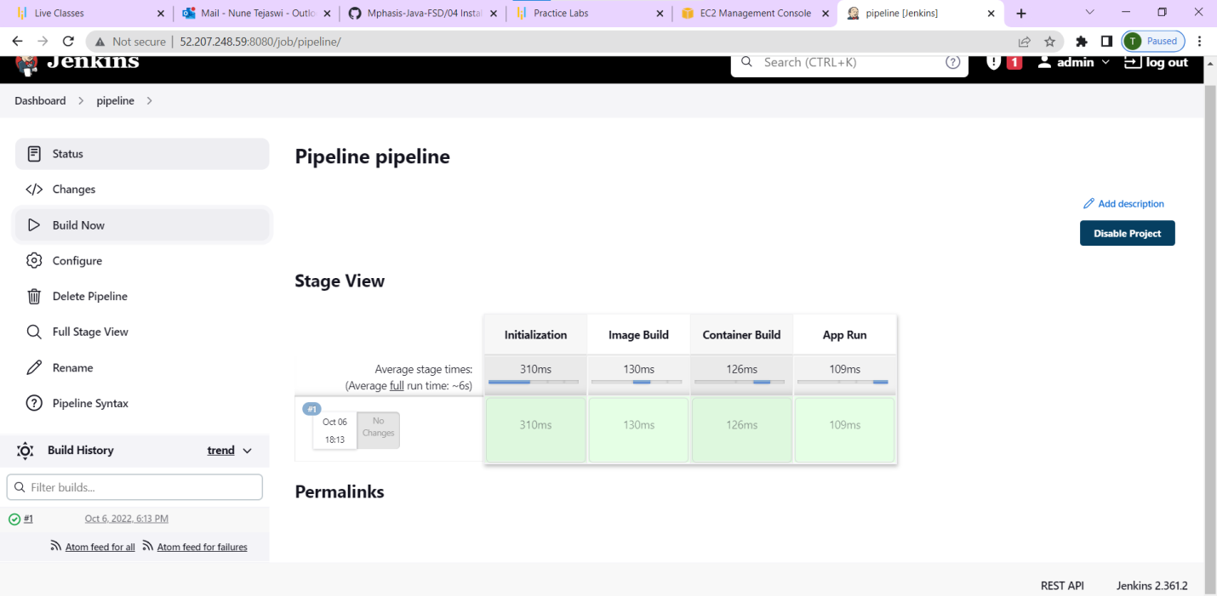

**>Console output**

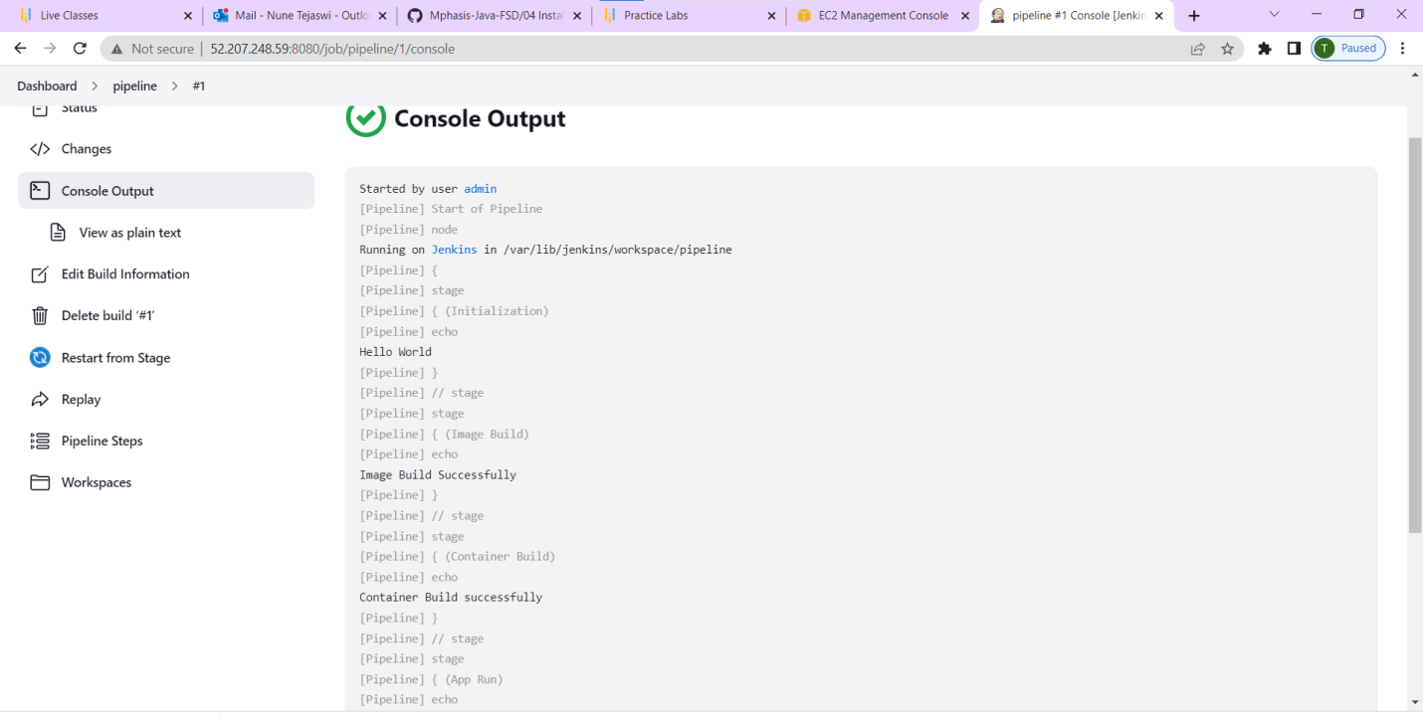

Started by user [admin](http://52.207.248.59:8080/user/admin)

[Pipeline] Start of Pipeline

[Pipeline] node

Running on [Jenkins](http://52.207.248.59:8080/computer/(built-in)/) in /var/lib/jenkins/workspace/pipeline

[Pipeline] {

[Pipeline] stage

[Pipeline] { (Initialization)

[Pipeline] echo

Hello World

[Pipeline] }

[Pipeline] // stage

[Pipeline] stage

[Pipeline] { (Image Build)

[Pipeline] echo

Image Build Successfully

[Pipeline] }

[Pipeline] // stage

[Pipeline] stage

[Pipeline] { (Container Build)

[Pipeline] echo

Container Build successfully

[Pipeline] }

[Pipeline] // stage

[Pipeline] stage

[Pipeline] { (App Run)

[Pipeline] echo

App is running successfully

[Pipeline] }

[Pipeline] // stage

[Pipeline] }

[Pipeline] // node

[Pipeline] End of Pipeline

Finished: SUCCESS